

Dr. William, Wise inc.
2020-03-12
Dr. Wise
148 Maureen Manor Apt. 383, Brownland, OK 05876
Phone: 7206679820
Fax: 137625765

Re: Patricia, Mcgee
PHN: 5827508791
Birthdate: 10-Jan-1989
Address: PSC 5649, Box 7918, APO AE 96576
Patient number: 5118958953

To Whom It May Concern:

This is a medical letter to state the above patient is pregnant with expected delivery date of 17-Mar-2025. Hoping this information is satisfactory for your requirements.

Thank you.

Sincerely,
Dr. William, Wise
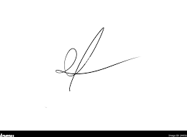
FRCS© NCMP
Clinical Assistant Professor, UBC
Department of Obstetrics and Gynecology SMH

